QUES 3: Apply branch security and locks

SOLN:

What is Branch Security?
Branch security in Azure DevOps lets you control who can read, write, or delete a specific branch (like main or master). You can grant or restrict permissions such as:
- Who can push code (contribute)
- Who can force push
- Who can manage branch policies

What is a Branch Lock?
Branch locking is a manual lock that:
- Prevents all changes (no pushes, no pull requests)
- Even blocks changes by administrators
- Used in critical branches (like main) to freeze code

Real-life Use Case (Explain in Assessment):
- Teams often use branch security and locks to protect their production or release branches.
- It ensures that only trusted members (admins) can change these branches.
- Prevents accidental or unauthorized code changes.
- Locks can be used temporarily when code is under review or deployed.
- This ensures code stability, auditing, and compliance in real DevOps pipelines.

Step 1: Apply Branch Security

Steps:
- Go to Project Settings > Repositories
- Select your repository.
- Click Security
- Scroll to Git refs permissions
- Click on All Branches → then select:

refs/heads/main (or master)
- Assign permissions as:
Group | Contribute | Force Push | Bypass Policies | Read
Project Administrators | ✅ Allow | ✅ Allow | ✅ Allow | ✅ Allow
Contributors | ❌ Deny | ❌ Deny | ❌ Deny | ✅ Allow

This restricts normal users from pushing, and only admins can manage code.
Things You Can Do with Branch Security in Azure DevOps:

1. Granular Permissions
Here are the key permissions you can apply to a branch (refs/heads/branch-name):
Permission | What It Controls | Example Use
Contribute | Allows pushing commits to the branch | Only Admins push to main
Force Push | Rewrite history, delete branches/tags | Usually Denied to all
Create Branch | Who can create new branches | Limit branch sprawl
Delete or disable | Deletes branch | Prevent accidental deletion
Manage Permissions | Who can edit security on this branch | Lock down access
Edit Policies | Who can set branch policies (like PR checks) | Admin-only setting

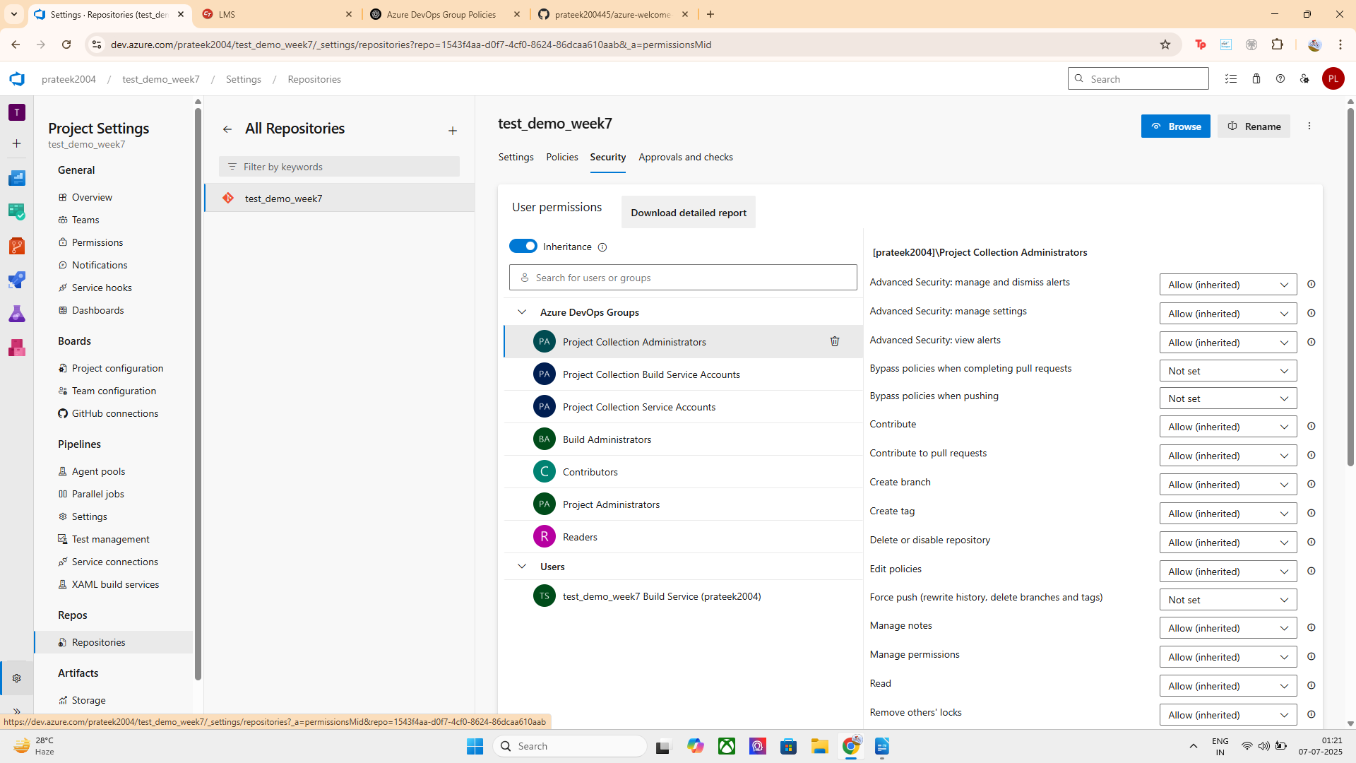
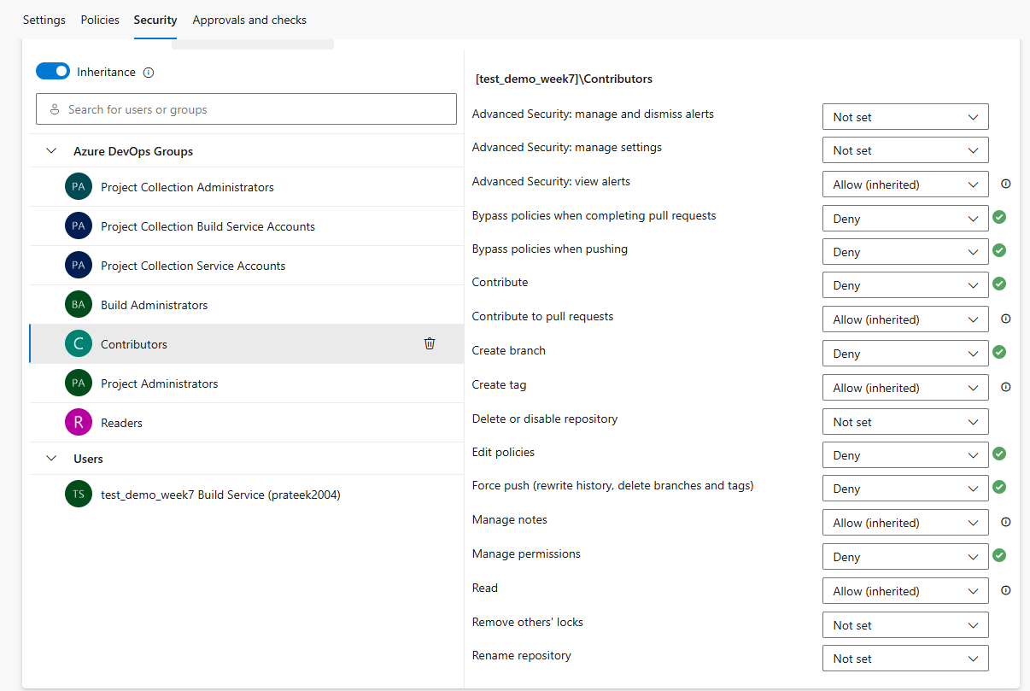
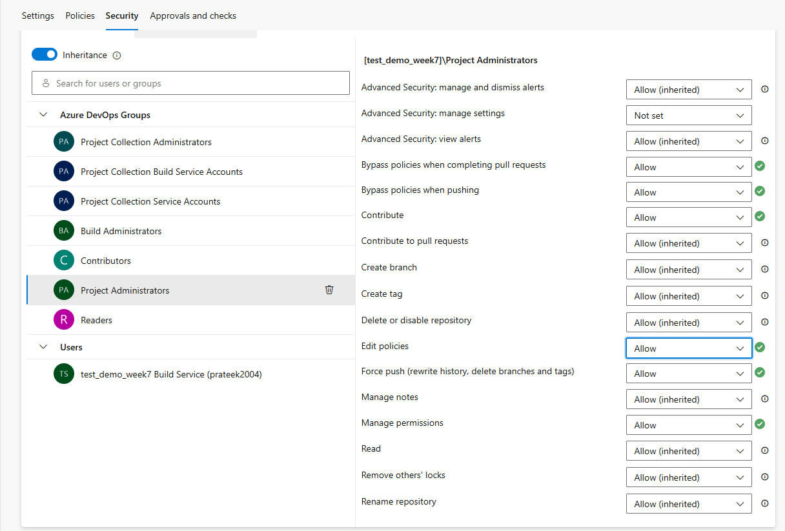
HENCE ITS SUCCESSFULLY CONFIGURED

2. Apply to Groups or Individuals
- You can assign security at user level or group level (e.g., Contributors, Readers).
- Best practice: use groups for easier management.

STEPS: Apply to Groups or Users
Instead of adding each person manually:
- Go to Project Settings > Teams
- Add users to:
  - Contributors for limited access
  - Project Administrators for full access
Why?
➡ Managing by group is easier and scalable
➡ You can change access for many users with one click.

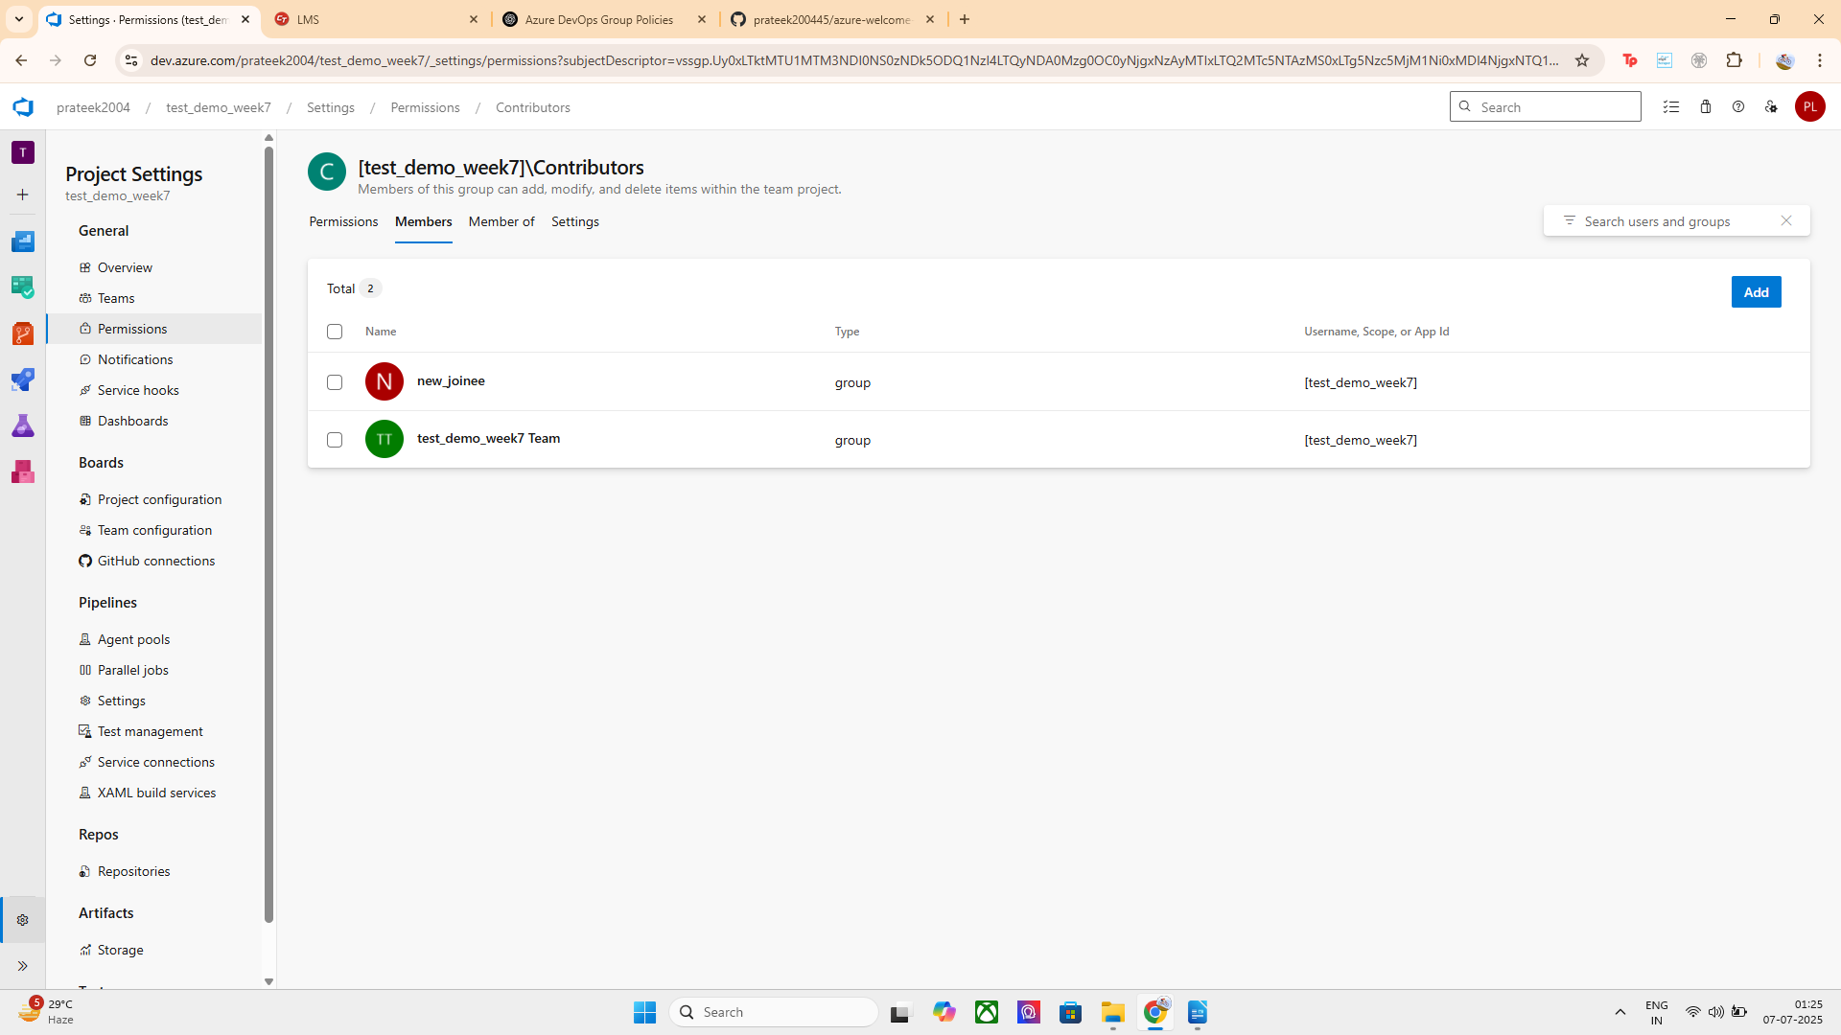

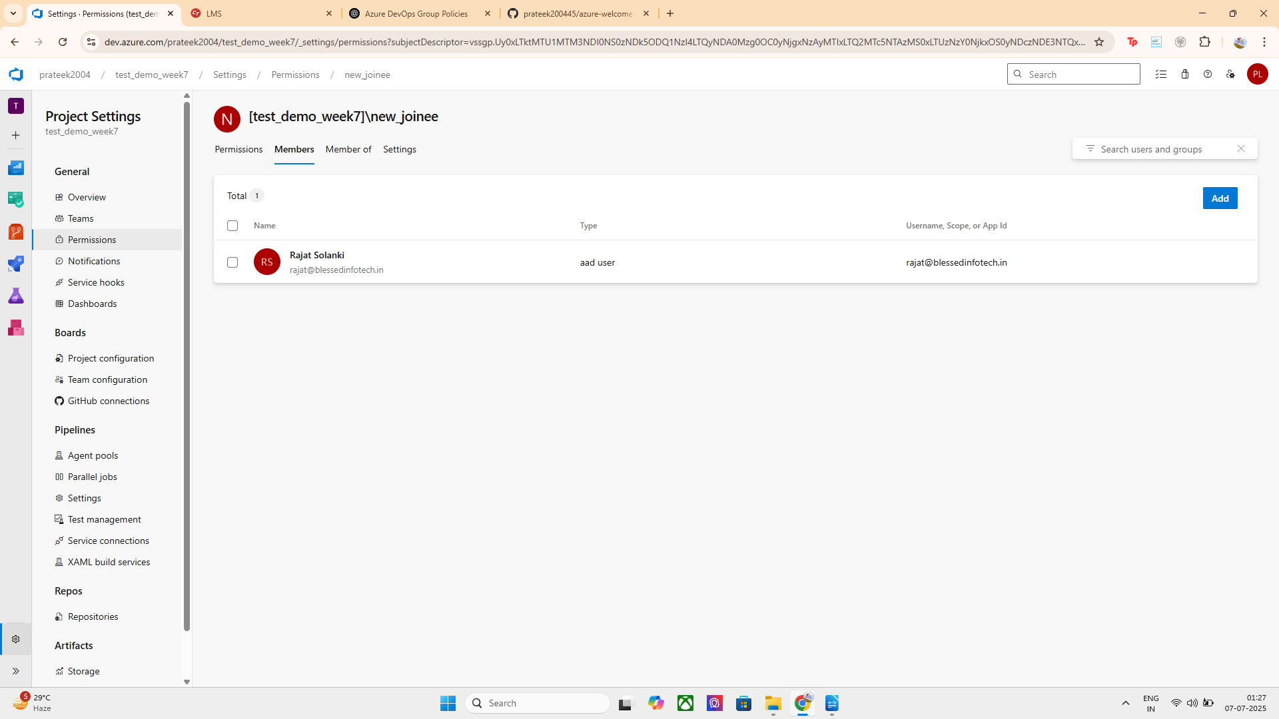
FOR POJECT ADMINSTRATORS:

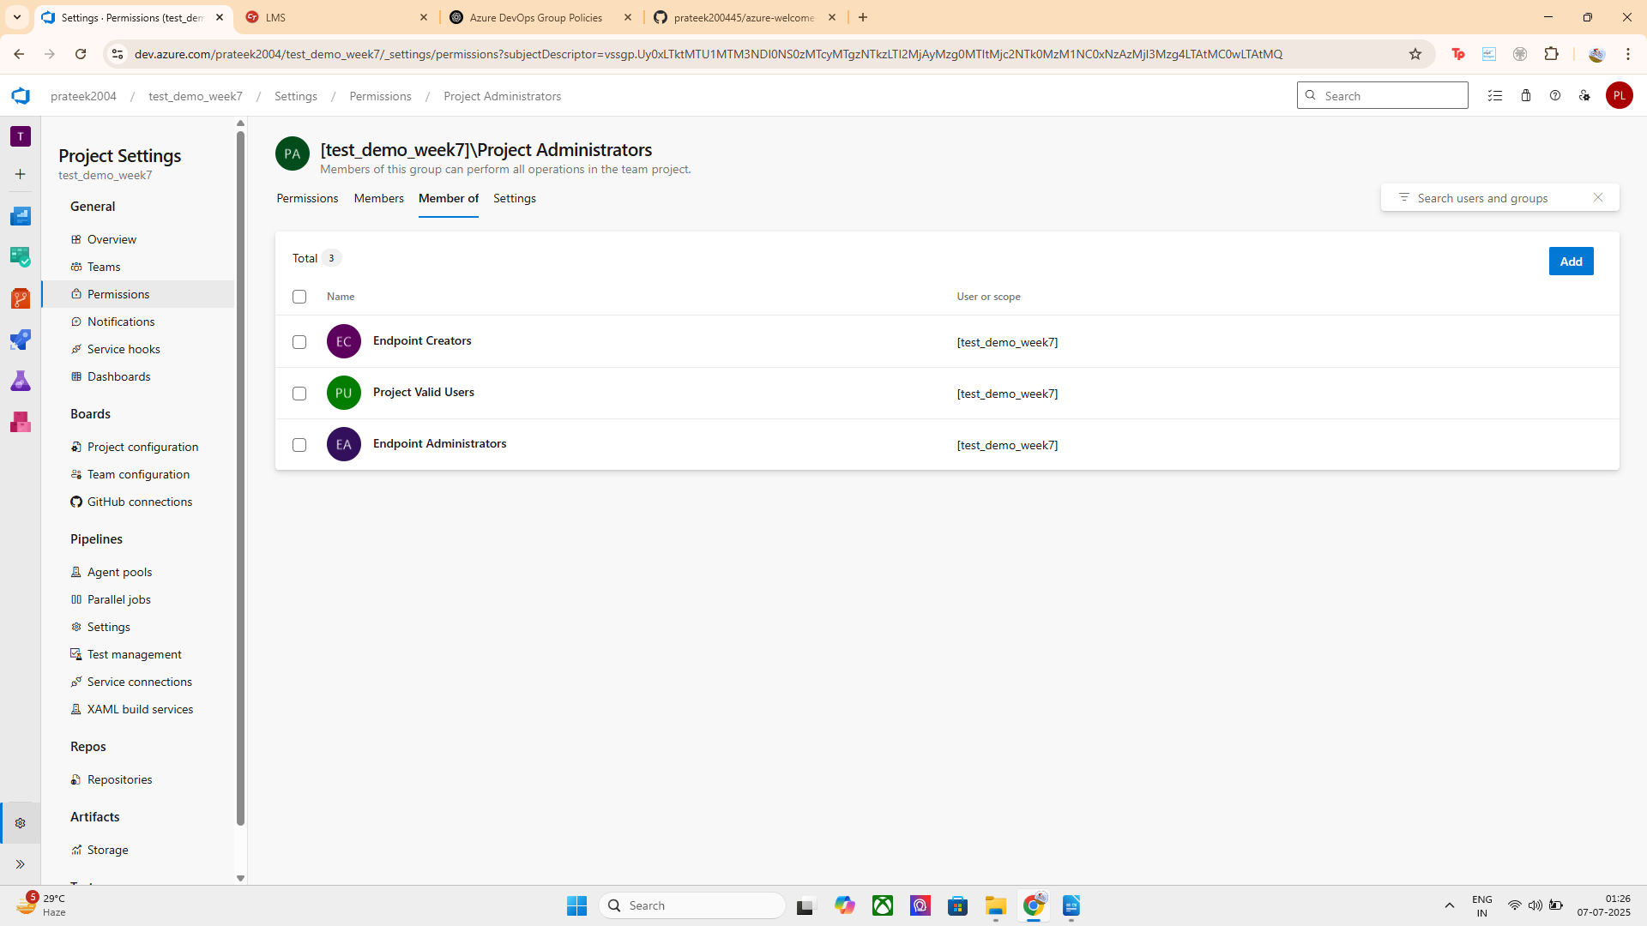
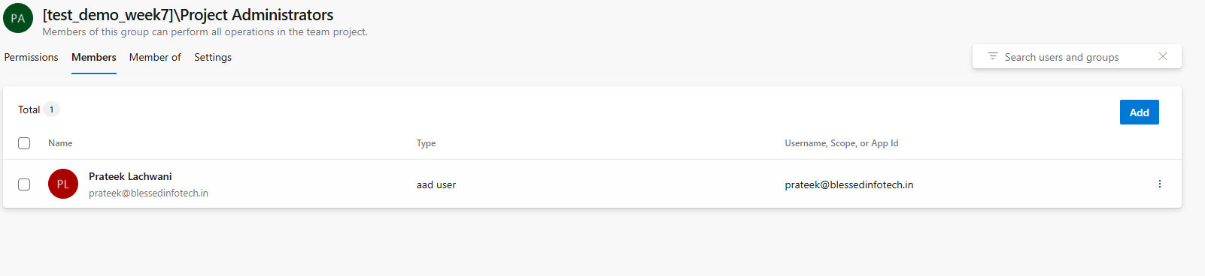

3. Inheritance Control
- Azure DevOps permissions are inherited from parent (repo or project).
- You can toggle Inheritance OFF to override.

STEPS: Turn OFF Inheritance (if needed)
By default, branch permissions are inherited from the repo.
You can:
- Go to Project Settings > Repositories > [Your Repo] > Security
- Under User Permissions, toggle:
Inheritance = OFF
Use this when you want a branch (like main) to have its own unique rules.

4. Read-Only Access
- You can allow users to just view the branch (Read = ✅), but deny all changes.
- Useful for stakeholders or auditors.

STEPS: Read-Only Access
Give read-only access to roles like:
- Auditors
- Review-only testers

Steps:
- Go to the refs/heads/main permission section.
- Select Readers group.
- Set:
  - Read = ✅ Allow
  - Everything else = ❌ Deny
Result: Users can see code, but can’t push, pull, delete, or edit.

5. Combine with Branch Policies
Although separate, you can use Branch Policies + Security together:
- Security = Who can access
- Policy = What rules apply (like required reviews)
Example:
Deny Contribute to all,
but allow PRs with minimum 2 approvals to merge.

Steps to Add:
- Go to Repos > Branches
- Click ⋯ > Branch Policies on main
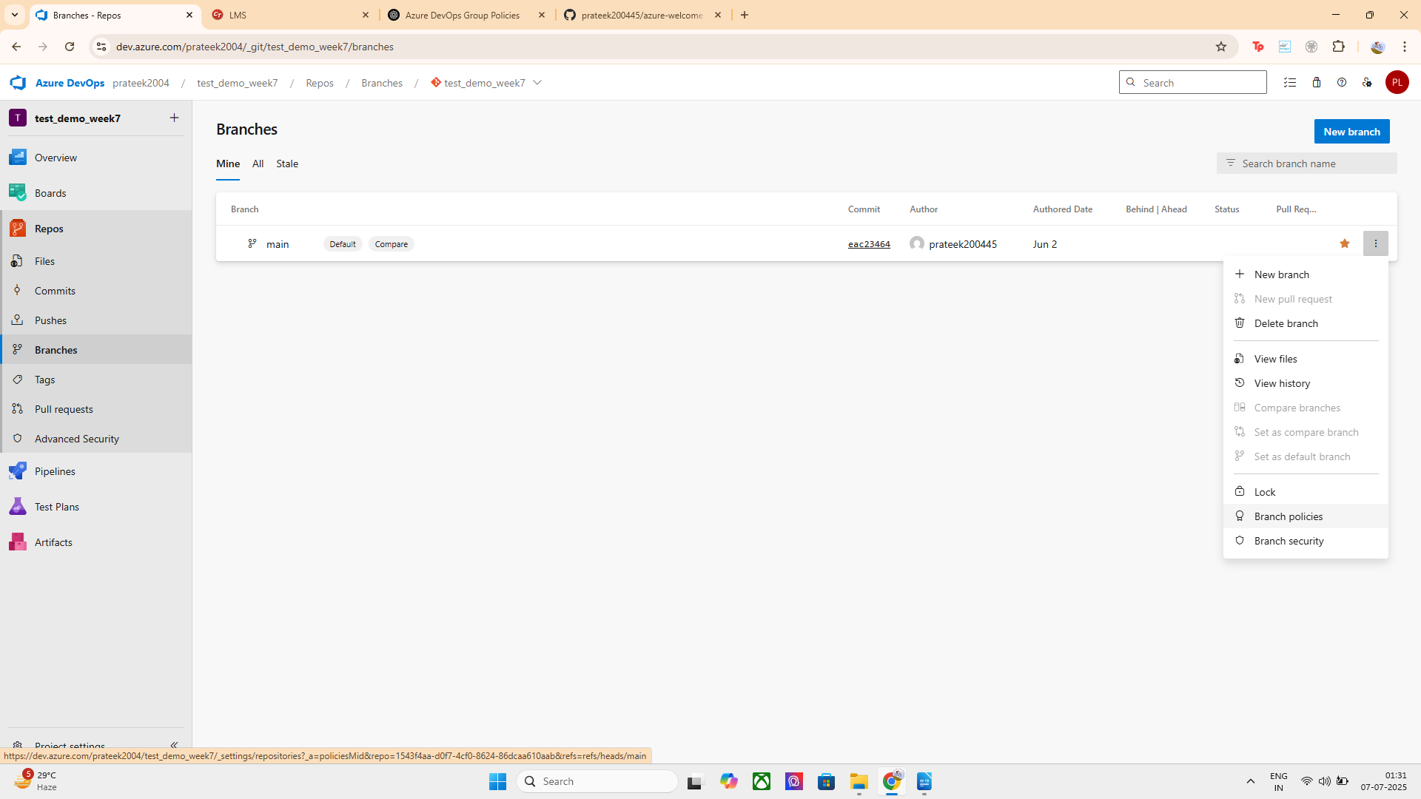
- Add required policies
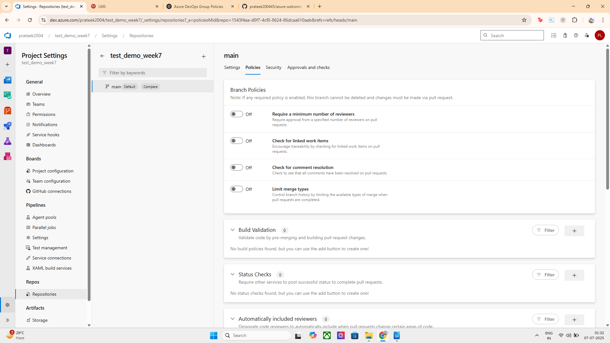

Advanced Use Cases:
Scenario | How Branch Security Helps
Freeze development temporarily | Lock the branch
Let QA team view but not edit code | Allow Read, deny Contribute
Prevent junior devs from deleting branches | Deny "Delete" permission
Allow bot to push releases only | Allow only to that user/bot

FINAL RESULT:
WE now have a complete, enterprise-level branch security model:
Layer | What We Did
Permissions | Granular control: Contribute, Delete, etc.
Group Usage | Managed via Contributors and Admins
Inheritance | Turned off if needed
Read Access | Granted to Read-only users
Policies | Set rules like approval, builds, status

PART 2 : Apply Branch Lock

Steps:
- Go to Repos > Branches
- Find the branch (main)
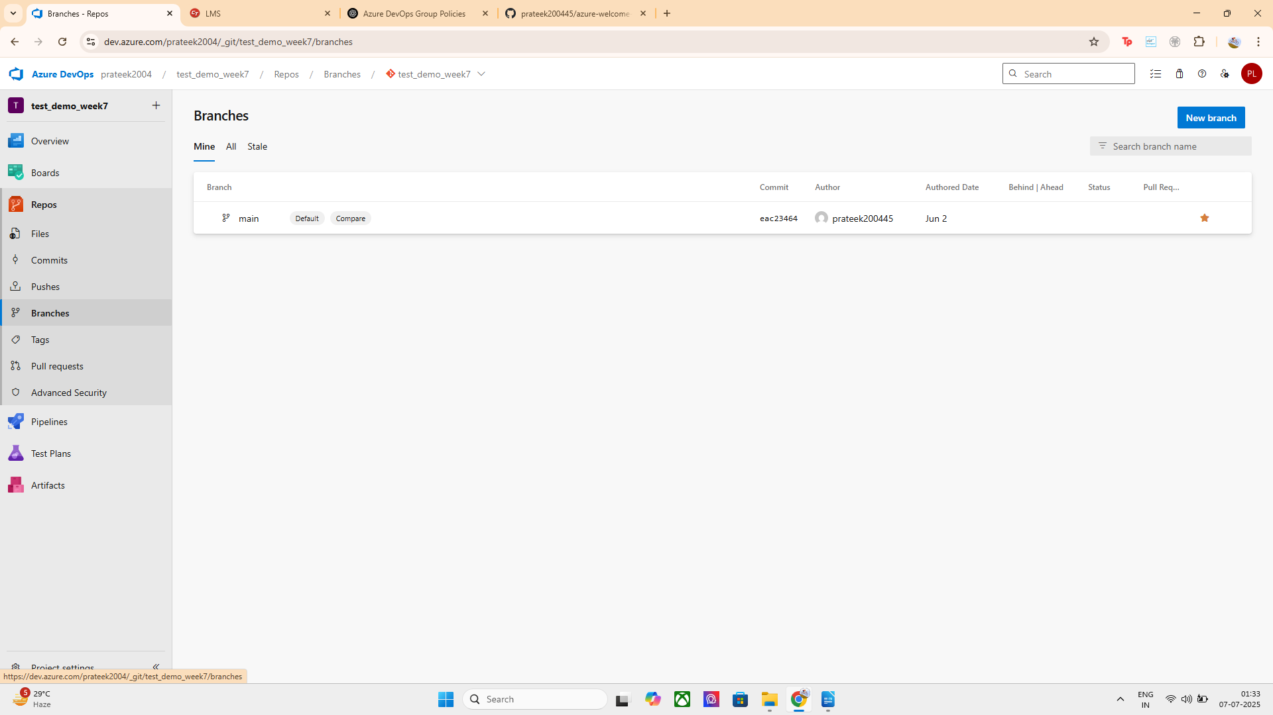
- Click the three dots ⋯ next to the branch

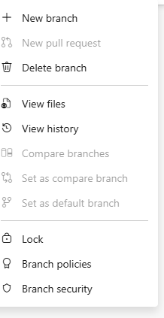

Click 🔒 Lock

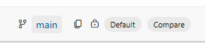
You’ll now see a lock icon (🔒) next to main.
⚠️ This prevents any push, PR, or deletion — even by admins — unless the branch is unlocked.

Branch security is used in Azure DevOps to restrict or allow access to specific Git branches. It helps teams protect important branches (like main or master) from unauthorized or accidental changes. Branch locks provide an extra layer of protection by freezing a branch entirely, blocking any code modifications — even by administrators.
In this implementation:
- I denied Contribute and Force Push permissions for the Contributors group.
- I allowed full permissions (like Contribute, Manage Permissions, Edit Policies) for the Project Administrators group.
- I configured these settings under Project Settings > Repositories > Security > Git refs permissions (refs/heads/main).
- I then applied a lock on the main branch by navigating to Repos > Branches > ⋯ > Lock.
This ensures that only trusted admins can modify the branch and it is fully protected from any unwanted or accidental changes. This setup enhances code stability, enables secure deployments, and supports collaborative development workflows in enterprise-grade DevOps environments.

